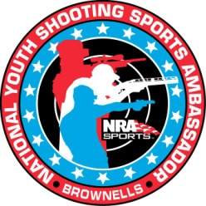

NRA’s Brownell National Youth Shooting Sports Ambassadors
Nomination Criteria

In addition to rewarding our most deserving youth shooters, we are organizing youth ambassadors who will be in the public eye and can contribute to a positive image of the shooting sports and of your respective youth organization. With that in mind, please consider the following guidelines:

- Participated in youth shooting sports to the extent that they can provide guidance and answer questions from other youth interested in the sport.
- Knowledgeable participant in your organization’s shooting sports program.
- Successfully spoken at public meetings and feels comfortable in front of an audience.
- 16-21years old during their year of service.
- Able to travel alone on air transportation for chaperoned trips (we will make every effort to minimize school and holiday conflicts).
- Available for quarterly conference calls from their hometown.
- Sign a release for public distribution of their photograph and biography for magazine and promotional materials.
- Able to write articles for their youth organizations publication.

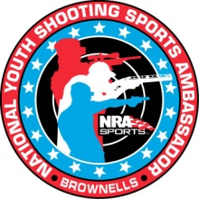

NRA’s Brownell National Youth Shooting Sports Ambassador Benefits and Responsibility

Ambassador Benefits
- Official NRA BNYSSA appointment letter for inclusion in their resume.
- Two thousand dollar award. One thousand dollars awarded upon
Submission of January/February Show Trip article and One thousand awarded upon completion of their term
- Uniform items to include jacket, pin and polo’s that they may keep after their term of service.
- All-expense paid trips to SHOT Show January 16- 19 2018 and NRA’s Annual Meeting May 3-7 2018.
- Other travel opportunities:
  - Upon prior approval subsidized travel to your organizational events.
  - Possible NRA events as need arises
- Opportunity to submit their article for publication in NRA Family Website

Ambassadors Responsibility
- Quarterly Conference Calls
- Represent your parent organization, National Rifle Association and Brownell National Youth Shooting Sports Ambassador to the best of your ability
- If not able to take part in scheduled call or trip you need to give advanced notification.
- Submit articles after Shot Show and if you attend another trip or function (possible additional awards).
- When on travel adhere to attached code of conduct and to your parent organization’s code of conduct and dress code
- Spending money for trips is your responsibility.
- Learn about the NRA and what programs are available
- Articles for publication in NRA magazines and the NRA Blog and articles for parent organizations publications.

Code of Conduct

The following rules and Code of Conduct apply equally to each BNYSSA member while en route to and during your attendance at a BNYSSA-sponsored event. Understanding, respecting and following this Code will assist the BNYSSA group, your chaperones and you in getting the most out of your experience and the time invested.

- I understand that I represent my Youth Organization and the Youth Shooting Program. I agree that my conduct shall at all times be courteous and respectful. I shall wear the designated BNYSSA Shooting Polo and Jacket or vest at all BNYSSA – sponsored events. I may also wear the logo of my parent Youth Organization in a way that presents a professional and complimentary appearance.

- I understand that I must follow directions provided to me by BNYSSA chaperones or else I can be removed from the program without further BNYSSA benefits, including the award check and travel opportunities.

- I will follow the schedule presented by BNYSSA staff and chaperones by arriving at meeting places at least 10 minutes early in order to facilitate transportation, meals interviews and event attendance.

- I understand that I am required to participate in all scheduled events. If I am unable to do so I will communicated with the staff and or my chaperone as early as I become aware of potential scheduling conflicts.

- I understand that the use of alcoholic beverages or illegal drugs is prohibited at all times during a BNYSSA event or trip. I understand and agree that any use of these items will result in automatic termination from the BNYSSA program and subject me to forfeiture of all BNYSSA benefits. I understand and agree to the strict enforcement of this rule.

- I understand that that theft, cheating or willful destruction of property will result in termination from the BNYSSA program and subject me to forfeiture of all BNYSSA benefits.

- I understand that quiet time begins at 10:00 p.m. nightly and must be observed by all BNYSSA participants. I am not allowed to leave the hotel without notifying the BNYSSA staff or chaperones. Curfew is at 11:00 p.m.

NRA/NHSRA Brownell’s National Youth Shooting Sports Ambassador Application
(Please complete the following form and follow instructions completely)
DEADLINE IS AUGUST 31, 2017! 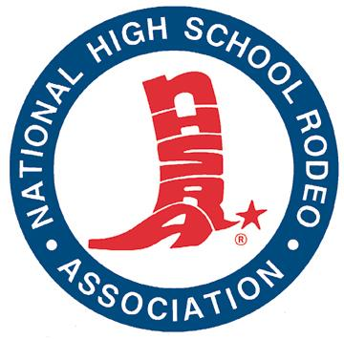
NAME ____________________________________________________
DATE _______________
ADDRESS ___________________________________________________________________
CITY ___________________________ STATE __________ ZIP_________________________
PHONE (_____)_______________________ EMAIL __________________________________
AGE _______ GRADE _______
SHOOTING DISCIPLINES YOU ARE INTERESTED IN OR COMPETE IN (RIFLE, TRAP, PISTOL, AIRGUN, HUNTING, etc.) ________________________________________________________________________________________________________________________________________________________
________________________________________________________________________________________________________________________________________________________
- Are you a current member of the NHSRA? Y OR N (CIRCLE ONE)
- Number of years you have been involved in shooting or shooting sports: ____________
- Are you 16 years of age or older? Y OR N (CIRCLE ONE)
- Can you travel alone? Y OR N (CIRCLE ONE)
- Do you have a desire to promote youth shooting sports? Y OR N (CIRCLE ONE)
- Are you knowledgeable about the NHSRA Shooting Sports Program? Y OR N (CIRCLE ONE)
- Are you available for an annual term (this fall to next summer)? Y OR N (CIRCLE ONE)
- Can you be available for quarterly (or more frequent) conference calls? Y OR N (CIRCLE ONE)
- Would you be willing to contribute shooting sports related articles to National Publications for the NRA and NHSRA? Y OR N (CIRCLE ONE)
Essay Question: In your own words, please tell me why you think you would be the best representative from the NHSRA to represent us as our National Youth Shooting Sports Ambassador for 2017-2018. (Please attach a separate sheet if necessary and submit this form along with your letter/essay by August 31, 2017) to: Lyn Ankeny c/o National High School Rodeo Association, 12011 Tejon Street, Suite 900, Denver, CO 80234 or send via email to lankeny@nhsra.org or fax to 303-452-0912. Selections will be made on or before September 1, 2017. If you are selected, you will be asked to submit an essay of not more than 800 words describing your shooting experience and personal biography as well as (2) photos for your publicity sheets; one action shot and one portrait.

Bonus questions: (Please feel free to answer one or more of these in your own words):

- What ideas do you have to increase participation and recognition of the NHSRA Shooting Sports Program?
- Does hunting help or hurt Wildlife Conservation? Explain your position.
- What are your future plans with respect to shooting sports (beyond High School)?

